YAMNA AFTAB
DECODESLAB INTERNSHIP
PROJECT # 4

Industrial Training Kit – Image and Object Recognition System Using OpenCV and MobileNet-SSD:

Abstract:
This project presents a basic Artificial Intelligence system for Image and Object Recognition using OpenCV and the MobileNet-SSD deep learning model. The system processes an input image, performs image preprocessing techniques such as grayscale conversion, Gaussian blurring, and thresholding, and then identifies objects present in the image. Detected objects are highlighted with bounding boxes and confidence scores. The project demonstrates the practical implementation of Computer Vision and AI techniques in object recognition applications.

Introduction:
Artificial Intelligence has transformed the field of computer vision by enabling machines to understand and interpret visual data. Image recognition systems are widely used in security surveillance, autonomous vehicles, healthcare, robotics, and smart applications.This project develops a basic AI-powered image recognition system ca pable of detecting and classifying objects in images using a pre-trained MobileNet-SSD model and OpenCV library.

Objectives:
The main objectives of this project are

To understand image preprocessing techniques.
To implement object detection using Artificial Intelligence.
To learn the use of OpenCV in computer vision applications.
To detect and classify objects in an image.
To display confidence scores and bounding boxes around detected objects.
Scope of the Project:
The system can be used in

Smart surveillance systems
Automated inspection systems
Robotics applications
Educational AI demonstrations
Object tracking and recognition systems

Tools and Technologies:
Software Requirements
Visual Studio Code
C++ Compiler (MinGW)
OpenCV Library
MobileNet-SSD Model
Hardware Requirements
Computer/Laptop
Minimum 4GB RAM
Intel Core i3 or above

Methodology:

The project follows the following steps

Step 1: Image Acquisition

The system loads an input image from the project directory.

Step 2: Image Preprocessing

The image is preprocessed to improve recognition accuracy.

Grayscale Conversion

Converts the colored image into grayscale.

Gaussian Blur

Removes image noise and smooths the image.

Thresholding

Converts the image into a binary format for better analysis.

Step 3: Feature Extraction

Important image information is extracted and prepared for the neural network model.

Step 4: Object Detection

The MobileNet-SSD model analyzes the image and identifies objects.

Step 5: Confidence Evaluation

Only detections having confidence greater than 80% are accepted.

Step 6: Result Visualization

Bounding boxes and labels are displayed around detected objects.

System Architecture:

Input Image

↓

Image Preprocessing

↓

Grayscale Conversion

↓

Gaussian Blur

↓

Thresholding

↓

MobileNet-SSD Detection Model

↓

Object Classification

↓

Confidence Filtering

↓

Bounding Box Generation

↓

Output Display

Algorithm:
Load image.
Convert image to grayscale.
Apply Gaussian Blur.
Apply thresholding.
Load MobileNet-SSD model.
Create image blob.
Feed blob into neural network.
Detect objects.
Check confidence score.
Draw bounding boxes.
Display detected object labels.
Show final output.
Dataset / Input:

The system uses an image file named:
input.jpg
The image may contain objects such as

Person
Car
Bicycle
Bus
Dog
Cat
Chair
Bottle

and other MobileNet-SSD supported classes

C++ Source Code:
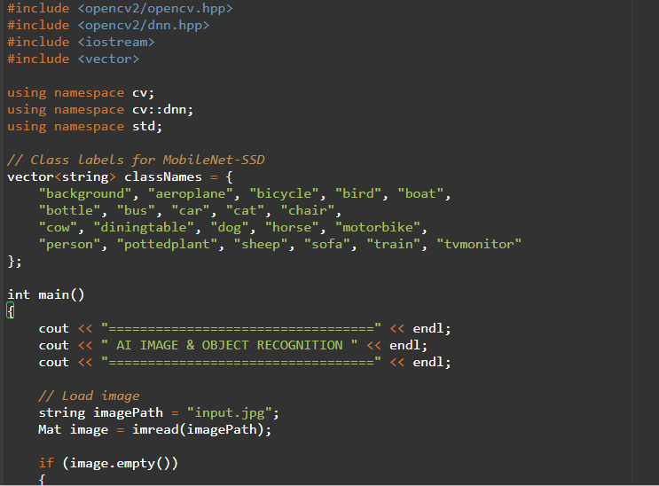

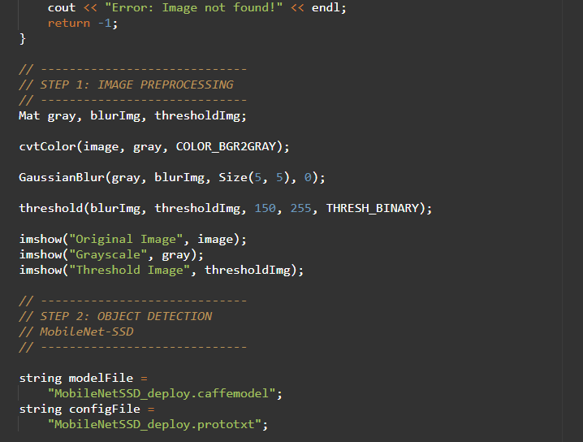
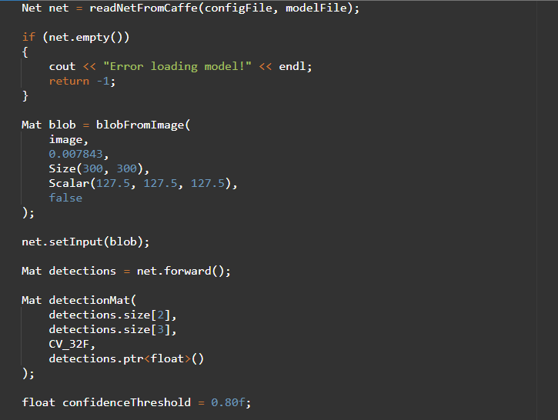

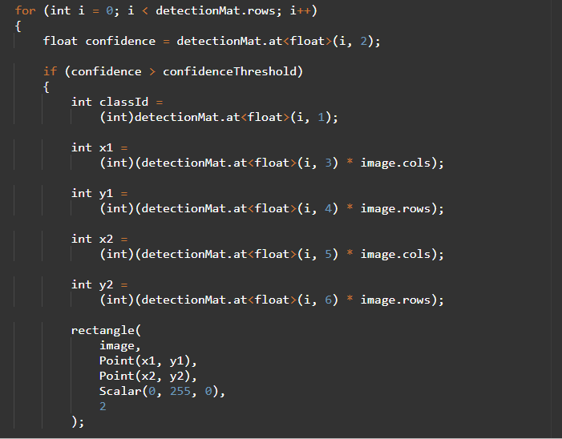

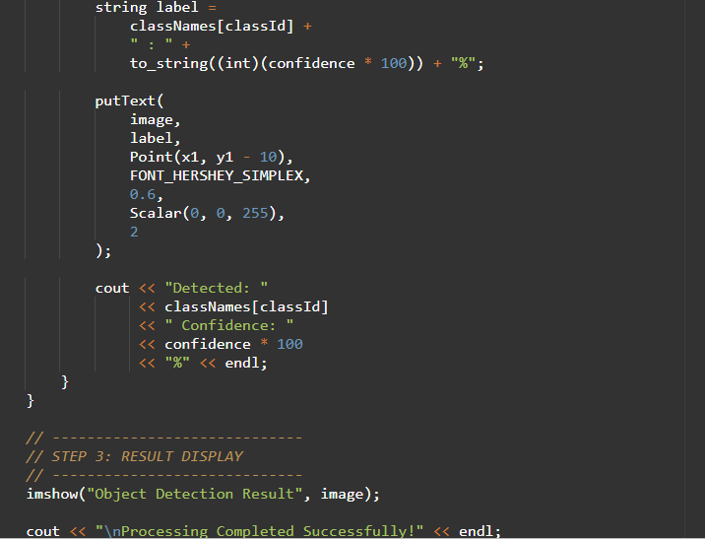

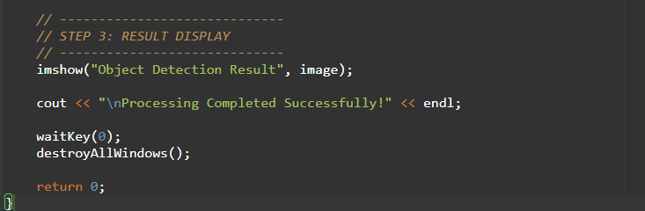
Output:
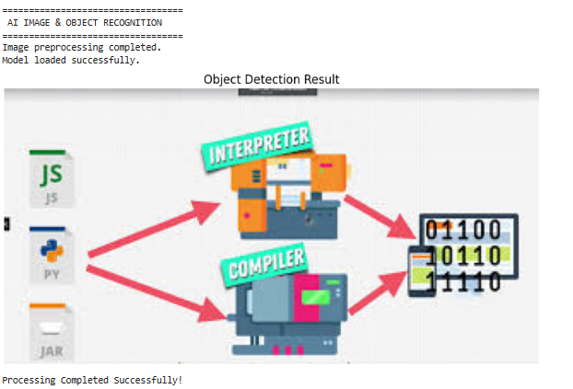

Future Enhancements:
Real-time webcam detection.
Face recognition integration.
OCR text recognition.
Video object tracking.
Deep learning model improvements.

Conclusion:
This project successfully demonstrates the use of Artificial Intelligence and Computer Vision for object recognition. By combining image preprocessing techniques with the MobileNet-SSD neural network model, the system accurately detects objects and displays their confidence scores. The project provides practical knowledge of OpenCV, deep learning, and image recognition systems and serves as a strong foundation for advanced AI applications.

References:
OpenCV Documentation
MobileNet-SSD Research Paper
Artificial Intelligence Course Material
Computer Vision Tutorials
Deep Learning Object Detection Resources

